📌 SmartCollab - User Manual (A+ Reward)

Table of contents
- Manage Contract/Agreement
  - Create matter
  - Review matter
    - Basic Information Card
    - Matter Tag and Checklist
    - Relate Matter
    - Contract Manaement
    - Matter Members
    - Comments
  - Close matter
  - Search matter
- Manage Project
  - Create matter
  - Review matter
    - Basic Information Card
    - Matter Tag and Checklist
    - Relate Matter
    - Contract Management
    - Matter Members
    - Comments
  - Close matter
  - Search matter
- Manage Marketing campaign
  - Create matter
  - Review matter
    - Basic Information Card
    - Matter Tag and Checklist
    - Relate Matter
    - Material Management
    - Matter Members
    - Comments
  - Close matter
  - Search matter
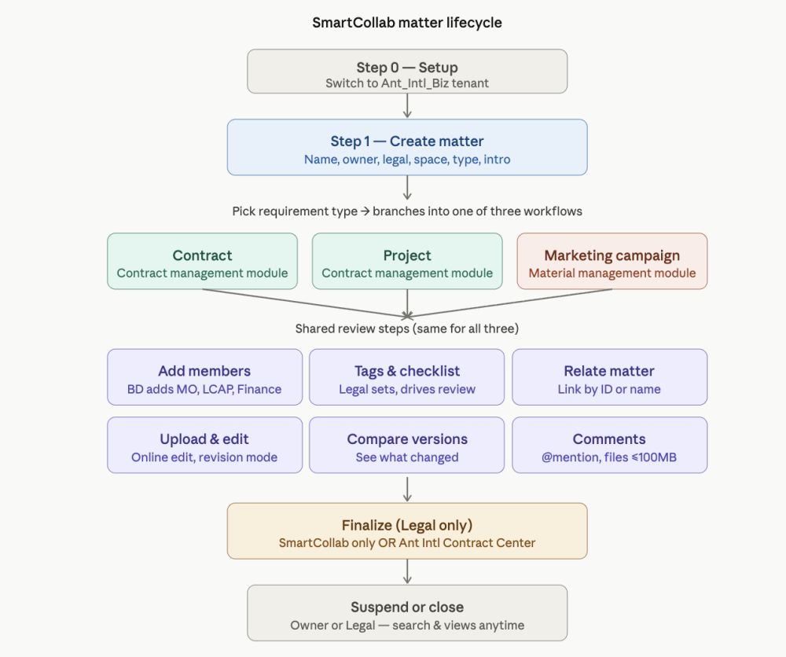
# | Step | What to do | Who does it | Key things to remember
0 | Setup | Make sure you're on the Ant_Intl_Biz tenant before doing anything. | Everyone | Wrong tenant = nothing works.
1 | Create matter | Homepage → Create matter → fill in name, Business Owner, Legal, members, Space, Requirement Type, brief intro → click Create matter. | Requestor (usually BD) | Pick the right Requirement Type: "Contract" / "Project" / "Marketing activities and materials". You can also copy a previous matter from the homepage.
2 | Add members | Search by name or employee number, click OK. | Business Owner, Legal, or any Member | BD MUST add: Middle Office (WenJing, YueTing, Lanxin), LCAP relevant members, Finance (Angel). Business Owner & Legal cannot be deleted.
3 | Basic Info Card | Click Edit to update if details change. | Anyone with access | For Marketing: Space and Requirement Type cannot be changed after creation.
4 | Tags & Checklist | Legal adds tags; each tag pulls a checklist to guide review. | Legal only | Helps Legal not miss anything.
5 | Relate Matter | Click Edit in the Relate Matter module → search by matter ID or name. | Any member | Use this when the matter ties to another existing one.
6a | Contract Mgmt (Contracts & Projects) | Add Contract Card → Upload Contract / Upload Attachment → edit online with revision mode → comment inline → compare versions. | All members can edit; only Legal can finalize | Multiple contracts per matter allowed. Version comparison highlights changes.
6b | Material Mgmt (Marketing only) | Upload T&C, POSM (images), or Other materials. | Members upload; Legal finalizes | Finalized version = the one accepted by all parties.
7 | Finalize | Choose Finalize in SmartCollab only OR Submit to Ant International Contract Center (this triggers the official approval flow). | Legal only | SmartCollab auto-converts Word → PDF. Check formatting before submitting.
8 | Comments | Use @mention to loop people in. | Anyone | @mentioned person auto-joins the matter and gets DingTalk + email notifications. File uploads ≤ 100MB.
9 | Suspend / Close | Click Suspend (freezes all activity) or Close (ends matter). | Business Owner or Legal only | Suspend = pause; Close = done.
10 | Search | Search box: by matter name or background keywords. Save filters as named Views for reuse. | Everyone | Views are the productivity hack — set them up once.

NB: Before all operations, please make sure you are on "Ant_Intl_Biz" now.
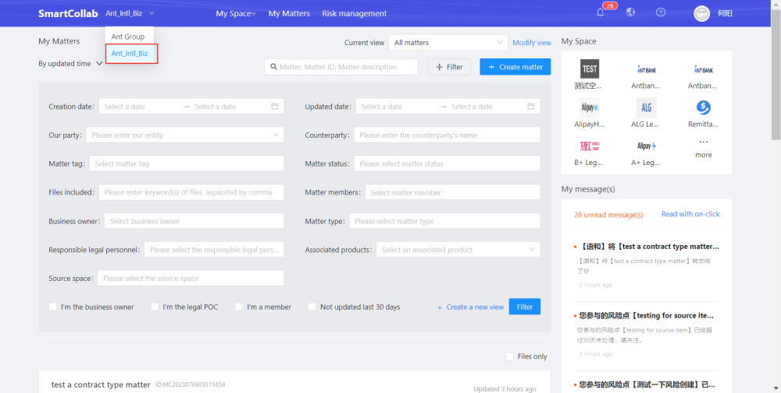

1. Manage Contract/Agreement

1.1. Create matter
Go to homepage, click Create matter.
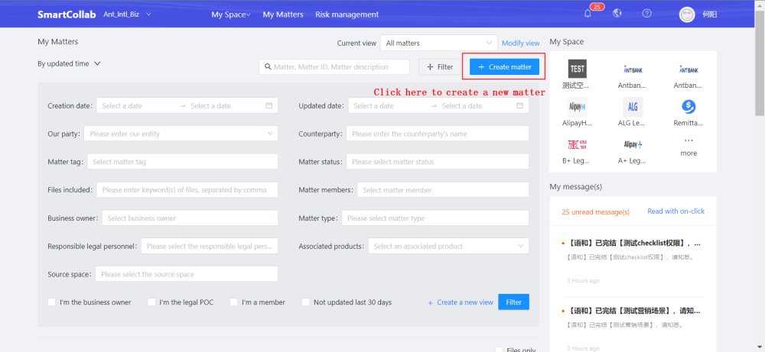
Enter the matter name and select the Business owner and Legal.
Add other corresponding person you want to involve in Matter members. Members can also be added on Matter details page after creation.
Choose Space. For example, if this matter is a case about Alipay+ core, please choose A+ Legal Space, or if it's a case related to global remittance, please choose Remittance Legal Space.
Choose Requirement type. For contract management, please choose“Contract”.
Briefly describe the background in Brief introduction.
Click Create matter, then a matter will be created successfully.
# | Step | What to do | Who does it | Key things to remember
0 | Setup | Make sure you're on the Ant_Intl_Biz tenant before doing anything. | Everyone | Wrong tenant = nothing works.
1 | Create matter | Homepage → Create matter → fill in name, Business Owner, Legal, members, Space, Requirement Type, brief intro → click Create matter. | Requestor (usually BD) | Pick the right Requirement Type: "Contract" / "Project" / "Marketing activities and materials". You can also copy a previous matter from the homepage.
2 | Add members | Search by name or employee number, click OK. | Business Owner, Legal, or any Member | BD MUST add: Middle Office (WenJing, YueTing, Lanxin), LCAP relevant members, Finance (Angel). Business Owner & Legal cannot be deleted.
3 | Basic Info Card | Click Edit to update if details change. | Anyone with access | For Marketing: Space and Requirement Type cannot be changed after creation.
4 | Tags & Checklist | Legal adds tags; each tag pulls a checklist to guide review. | Legal only | Helps Legal not miss anything.
5 | Relate Matter | Click Edit in the Relate Matter module → search by matter ID or name. | Any member | Use this when the matter ties to another existing one.
6a | Contract Mgmt (Contracts & Projects) | Add Contract Card → Upload Contract / Upload Attachment → edit online with revision mode → comment inline → compare versions. | All members can edit; only Legal can finalize | Multiple contracts per matter allowed. Version comparison highlights changes.
6b | Material Mgmt (Marketing only) | Upload T&C, POSM (images), or Other materials. | Members upload; Legal finalizes | Finalized version = the one accepted by all parties.
7 | Finalize | Choose Finalize in SmartCollab only OR Submit to Ant International Contract Center (this triggers the official approval flow). | Legal only | SmartCollab auto-converts Word → PDF. Check formatting before submitting.
8 | Comments | Use @mention to loop people in. | Anyone | @mentioned person auto-joins the matter and gets DingTalk + email notifications. File uploads ≤ 100MB.
9 | Suspend / Close | Click Suspend (freezes all activity) or Close (ends matter). | Business Owner or Legal only | Suspend = pause; Close = done.
10 | Search | Search box: by matter name or background keywords. Save filters as named Views for reuse. | Everyone | Views are the productivity hack — set them up once.
 | ANTOM GROWTH
Biz creates a matter on SmartCollab | 1、Go to SmartCollab https://tongzhouji.antgroup-inc.cn/tongzhouji/homePage  2、Select the "Ant_Intl_Biz" tenant at top left corner  3、Select Space: AtonM & AGH  4、Click“+ Create matter”  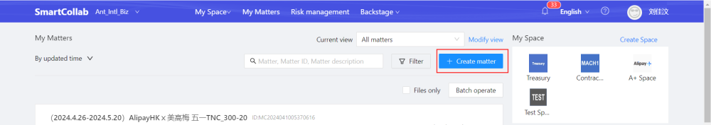  5、The matter can be created by the requestor  - BD MUST add related PIC  - Middle office: WenJing, YueTing, Lanxin  - LCAP relevant members: can consult MO if unclear  - Finance: Angel  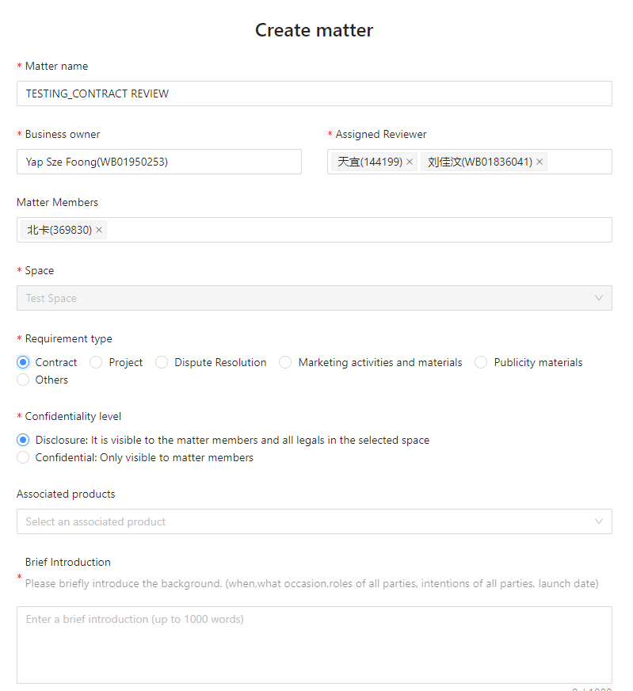  6、Add info of parties involved and Yuque/reference materials (file attachments and URLs are supported)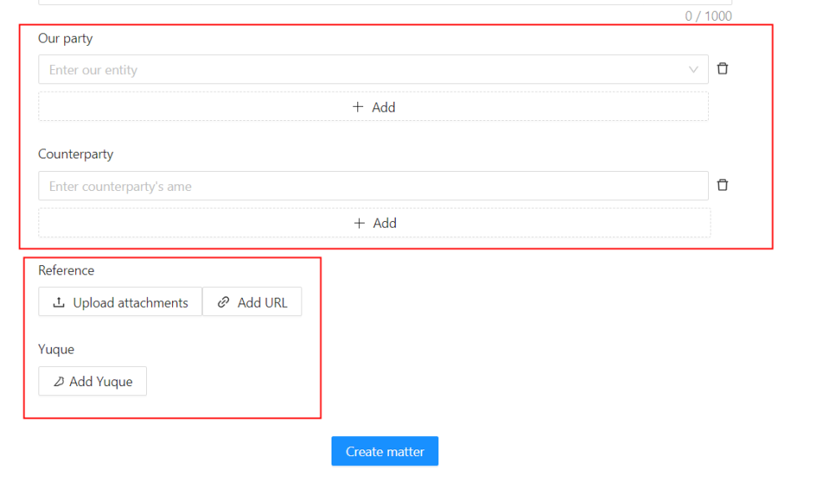  OR  Create a copy of an previous matter at homepage by clicking on the copy icon. The matter info will copied over to the newly created matter.  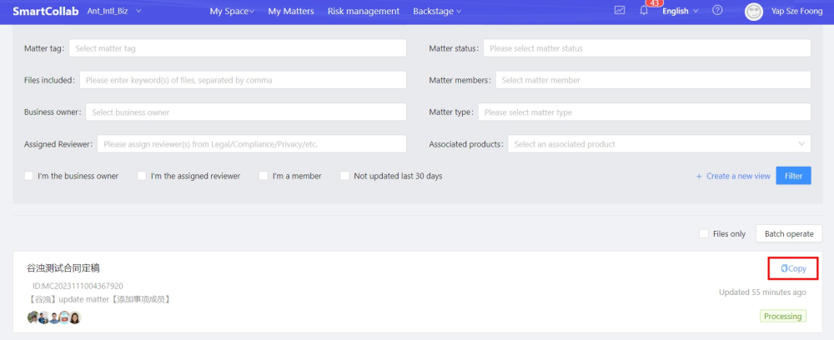

1.2. Review matter

1.2.1. Basic Information Card
If the basic information is incorrect or situation changes, you can click Edit to modify in Basic Information Card.
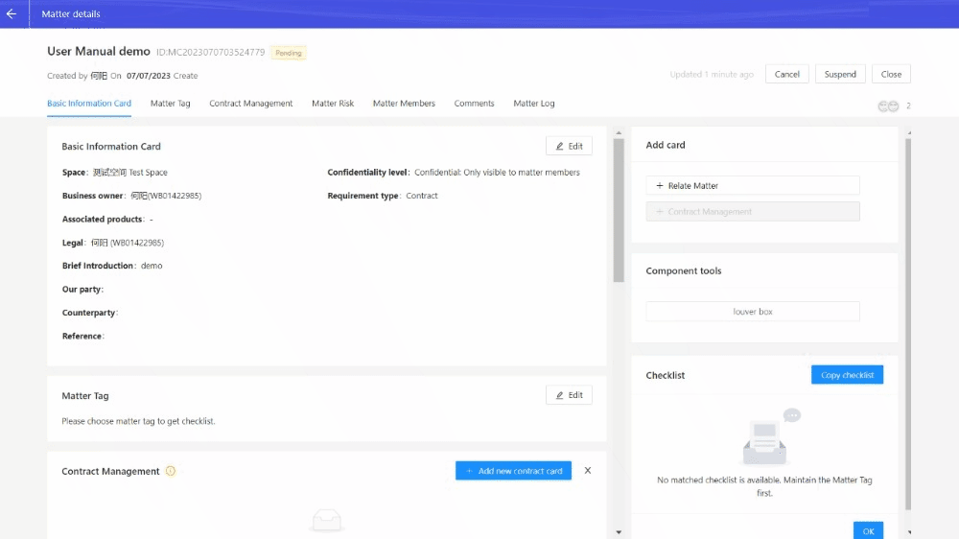

1.2.2. Matter Tag and Checklist
Legal can edit and add matter tags. Different matter tags are associated with different checklist.
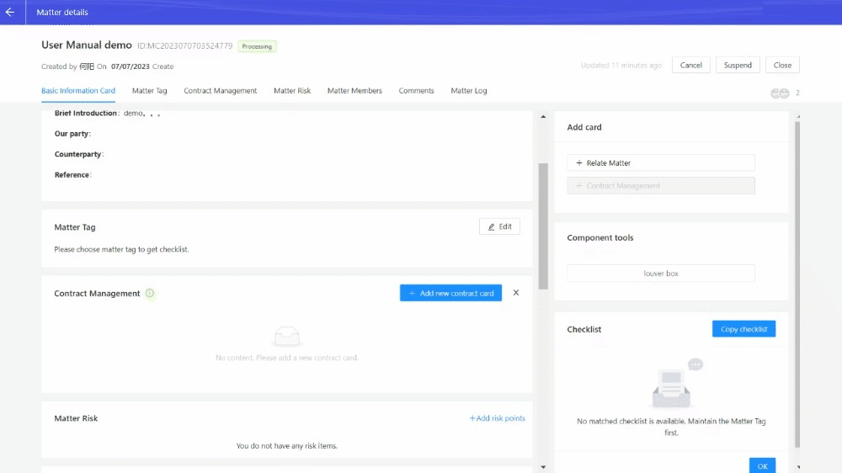
Checklist can be used to help legal's review.
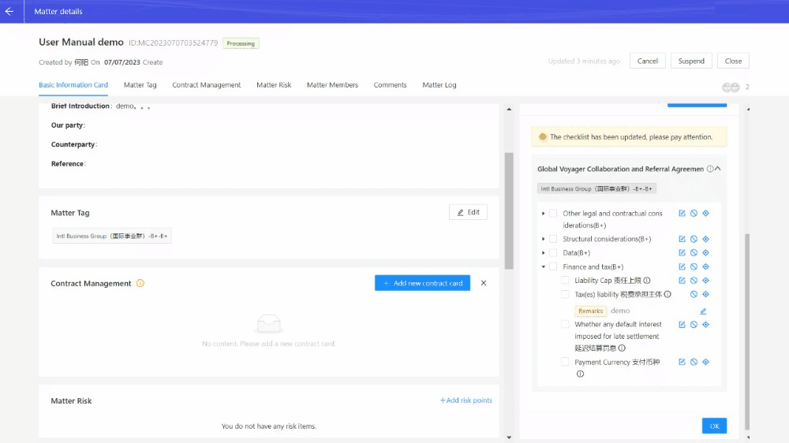

1.2.3. Relate Matter
If the matter is related to other matters, you can add related ones.
After adding the Relate matter module, please click Edit in Relate matter, and you can search by the matter ID or matter name to relate.
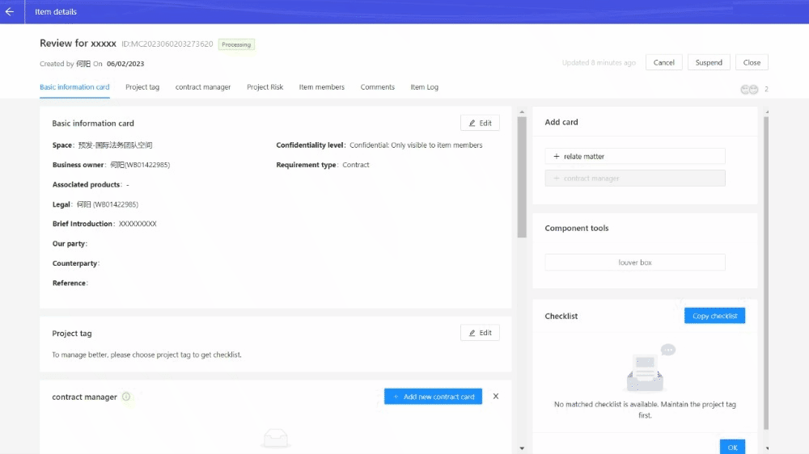

1.2.4. Contract Management
Since you choose the requirement type of "Contract", the matter details page will display the module of Contract management.

1.2.4.1. Upload
● To upload multiple contracts under one matter, click "Add Contract Card".
● To upload a new version of the current contract, click "Upload Contract".
● To upload an attachment for the current contract, click "Upload Attachment".
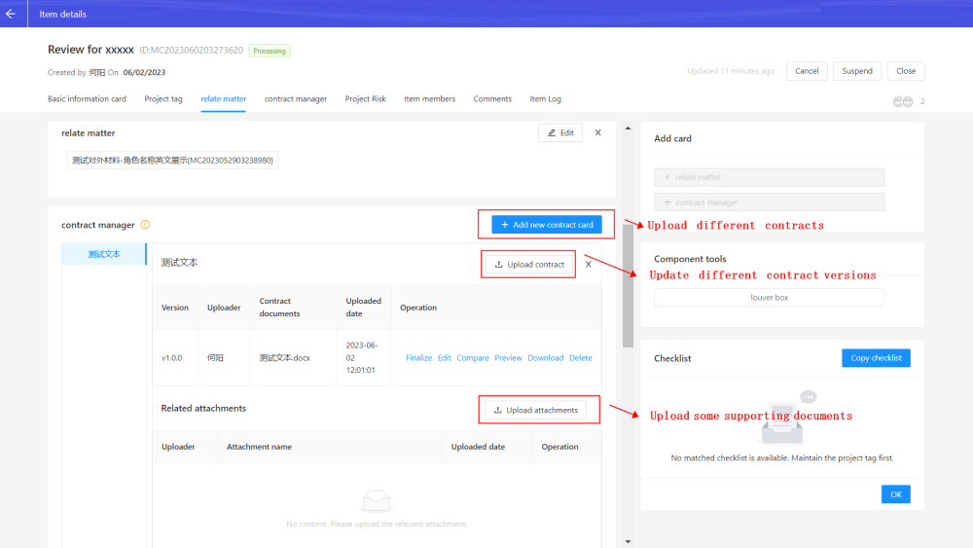

1.2.4.2. Edit

1.2.4.2.1. Role pemission
Before finalization, all members can edit contract.
Only Legal can finalize.

1.2.4.2.2. Edit operation
If you need to edit the contract text, you can edit it online and enable the revision mode.
[MISSING IMAGE: , ]
If you want to comment, you can select the text and insert the comment.
[MISSING IMAGE: , ]

1.2.4.3. Compare
Under one matter, if the contract has multiple version, comparison between the latest version and old version is supported. You can know which terms have been modified by comparison.

1.2.4.4. Finalize
Only Legal can finalize contract.which should be the newest version on Contract Management.
You can choose Finalize in SmartCollab only or Submit to Ant International Contract Center. The latter one will link to approval process on contract platform (Ant International Contract Center) if requirement information is enough.
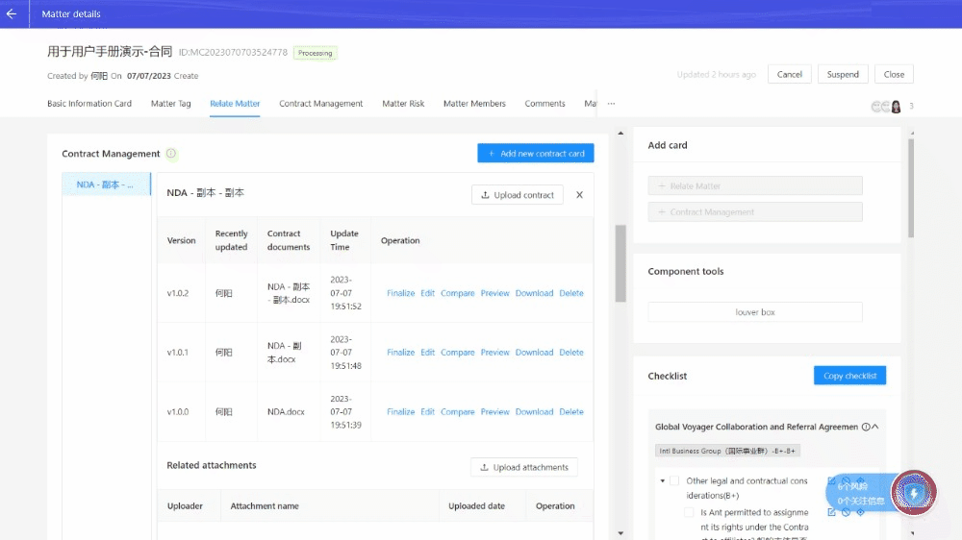
Fill in some requirement information, and click Finalize and initiate the process on the bottom right.
SmartCollab will convert your WORD format file into PDF version. Please make sure there are no problem in format and content.
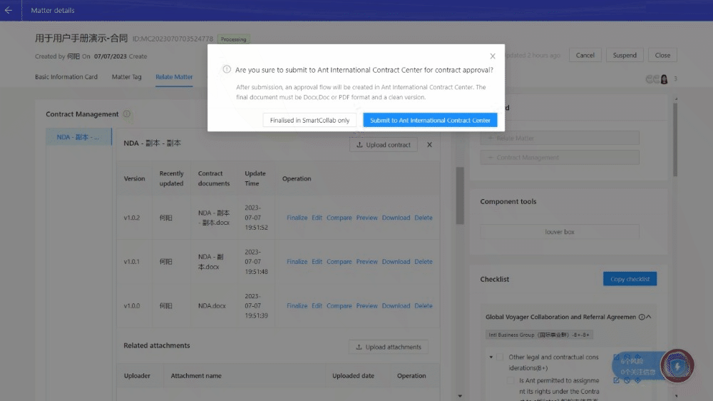

1.2.5. Matter Members
Click Add member, search person by his/her name or employee number. Select and click OK to add person into member list.
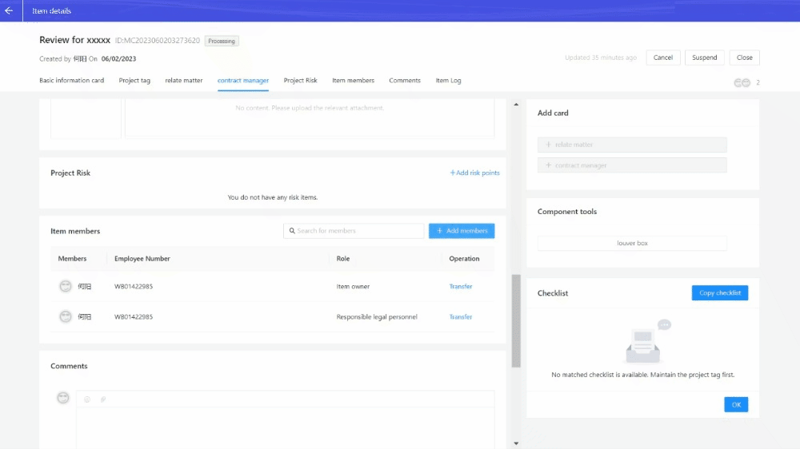
Different roles have different permission in matter member management.
Role Permission
 | Business owner | Legal | Members
add new member | √ | √ | √
delete business owner | × | × | ×
delete legal | × | × | ×
delete members | √ | √ | √
transfer | √ | √ | ×
quit | × | × | √

1.2.6. Comments
If you @person in Comments, the person will automatically become a member of the event and receive notifications through Dingding and email.
Files within 100MB are supported to upload in Comments.
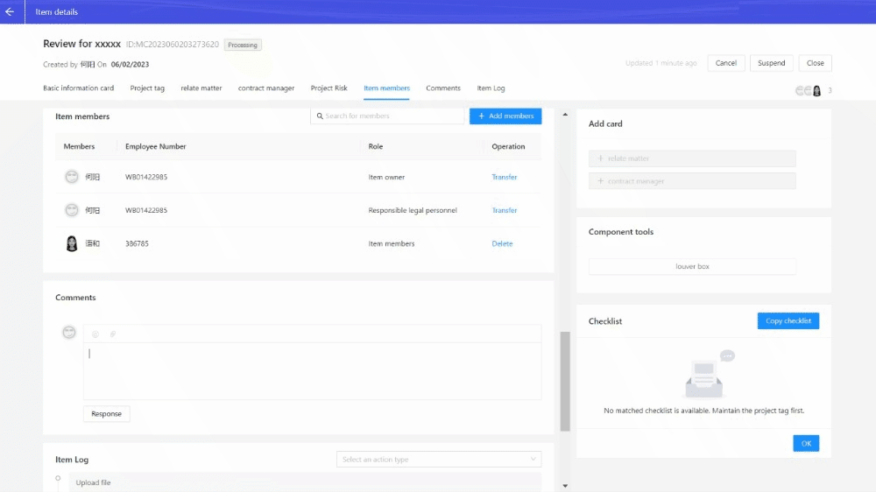

1.3. Suspend and Close matter
Business owner and Legal can click Close button to close the matter, and click Suspend button to suspend the matter, which will make all operations in this matter frozen.
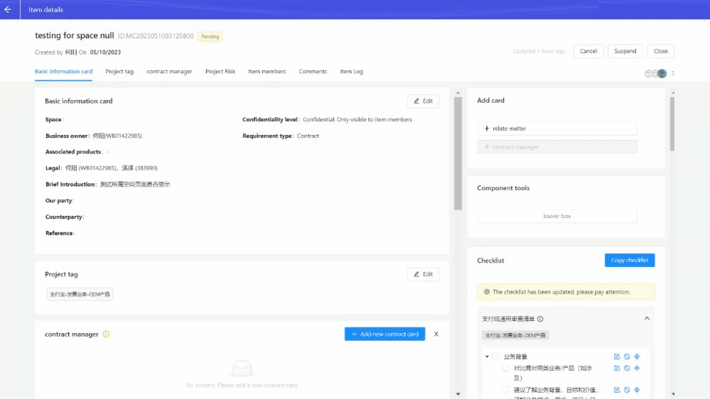

1.4. Search matter
Search by keywords of matter name or matter background in the search box is supported.
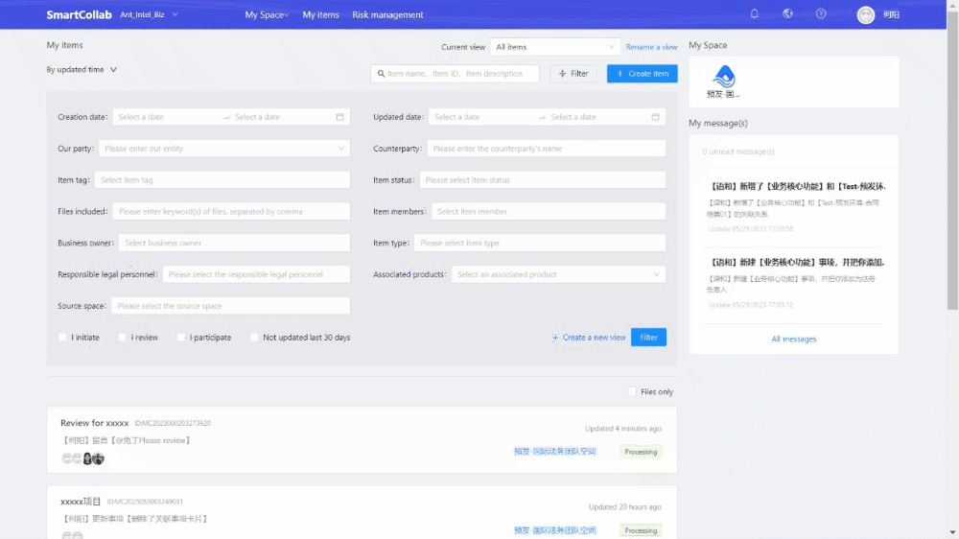
Click create a new view and name it so that you can save different filters as a view. Switching among diffrent views can help your efficiency improval.
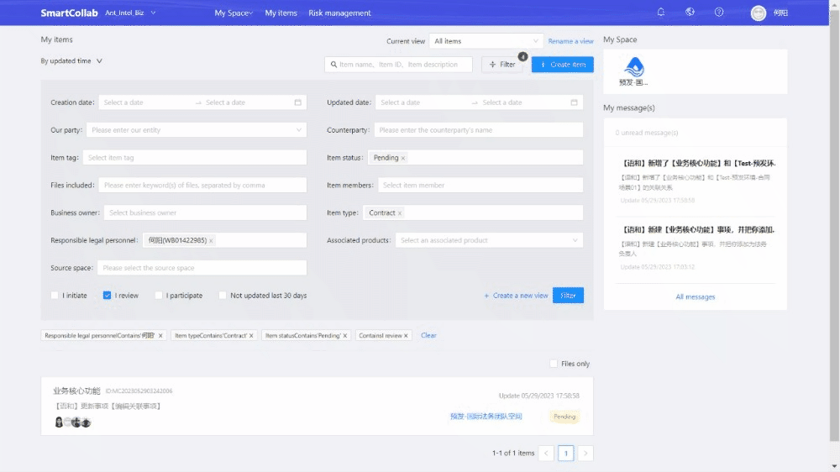

2. Manage Project

2.1. Create matter
Go to homepage, click Create a matter.

Enter the matter name and select the Business owner and Legal.
Add other corresponding person you want to involve in Matter members. Members can also be added on Matter details page after creation.
Choose Space. For example, if this matter is a case about Alipay+ core, please choose A+ Legal Space, or if it's a case related to global remittance, please choose Remittance Legal Space.
Choose Requirement type. For project management, please choose“Project”.
Briefly describe the background in Brief introduction.
Click Create matter, then a matter will be created successfully.
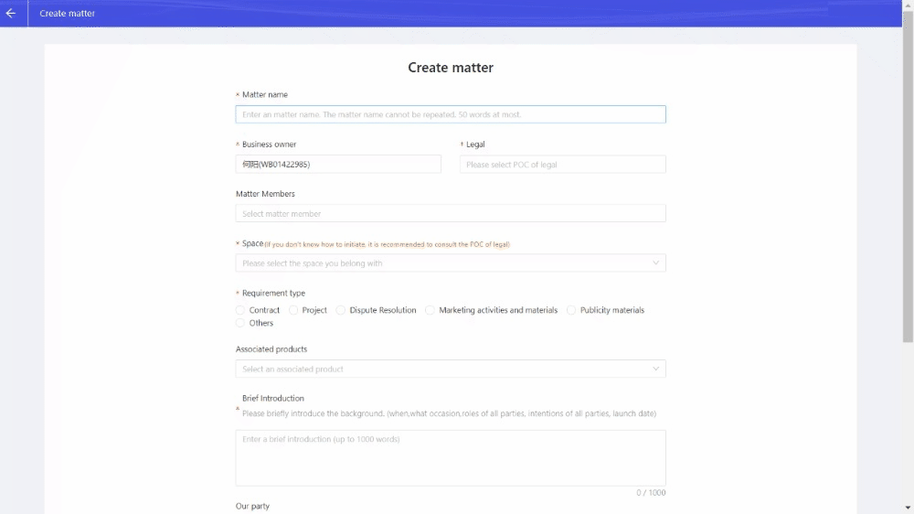

2.2. Review matter

2.2.1. Basic Information Card
If the basic information is incorrect or situation changes, you can click Edit to modify in Basic Information Card.
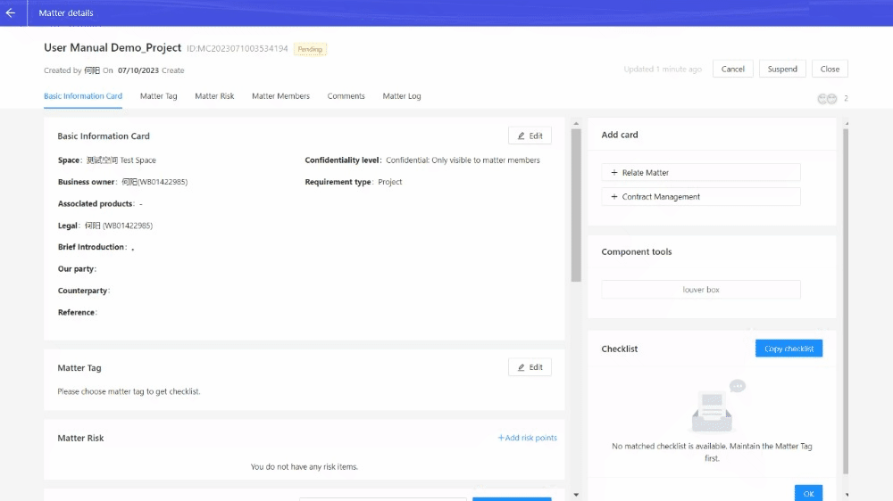

2.2.2. Matter Tag and Checklist
Legal can edit and add matter tags. Different matter tags are associated with different checklist.

Checklist can be used to help legal's review.


2.2.3. Relate matter
If the matter is related to other matters, you can add related ones.
After adding the Relate matter module, please click Edit in Relate matter, and you can search by the matter ID or matter name to relate.


2.2.4. Contract management

2.2.4.1. Add Contract management card
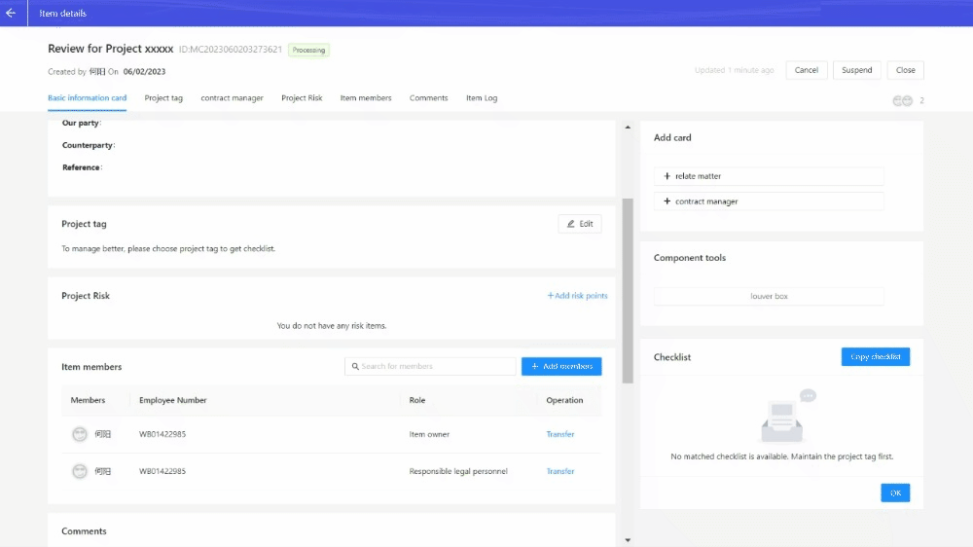

2.2.4.2. Upload
● To upload multiple contracts under one matter, click "Add Contract Card".
● To upload a new version of the current contract, click "Upload Contract".
● To upload an attachment for the current contract, click "Upload Attachment".


2.2.4.3. Edit

2.2.4.3.1. Role pemission
Before finalization, all members can edit contract.
Only Legal can finalize.

2.2.4.3.2. Edit operation
If you need to edit the contract text, you can edit it online and enable the revision mode.
[MISSING IMAGE: , ]
If you want to comment, you can select the text and insert the comment.
[MISSING IMAGE: , ]

2.2.4.4. Compare
Under one matter, if the contract has multiple version, comparison between the neweast version and old version is supported. You can know the part which have been modified by comparison.

2.2.4.5. Finalize
Only Legal can finalize contract which should be the newest version on Contract Management.
You can choose Finalize in SmartCollab only or Submit to Ant International Contract Center. The latter one will link to approval process on contract platform (Ant International Contract Center) if requirement information is enough.

Fill in some requirement information, and click Finalize and initiate the process on the bottom right.
SmartCollab will convert your WORD format file into PDF version. Please make sure there are no problem in format and content.


2.2.5. Matter members
Click Add member, search person by his/her name or employee number. Select and click OK to add person into member list.

Different roles have different permission in matter member management.
Role Permission
 | Business owner | Legal | Members
add new member | √ | √ | √
delete business owner | × | × | ×
delete legal | × | × | ×
delete members | √ | √ | √
transfer | √ | √ | ×
quit | × | × | √

2.2.6. Comments
If you @person in Comments, the person will automatically become a member of the event and receive notifications through Dingding and email.
Files within 100MB are supported to upload in Comments.


2.3. Suspend and Close Matter
Business owner and Legal can click Close button to close the matter, and click Suspend button to suspend the matter, which will make all operations in this matter frozen.


2.4. Search matter
Search by keywords of matter name or matter background in the search box is supported.

Click create a new view and name it so that you can save different filters as a view. Switching among diffrent views can help your efficiency improval.


3. Manage Marketing campaign

3.1. Create matter
Go to homepage, click Create matter.

Enter the matter name and select the Business owner and Legal.
Add other corresponding person you want to involve in Matter members. Members can also be added on Matter details page after creation.
Choose Space. For example, if this matter is a case about Alipay+ core, please choose A+ Legal Space, or if it's a case related to global remittance, please choose Remittance Legal Space.
Choose Requirement type. For marketing campaign management, please choose“Marketing activities and materials”.
Briefly describe the background in Brief introduction.
Click Create matter, then a matter will be created successfully.
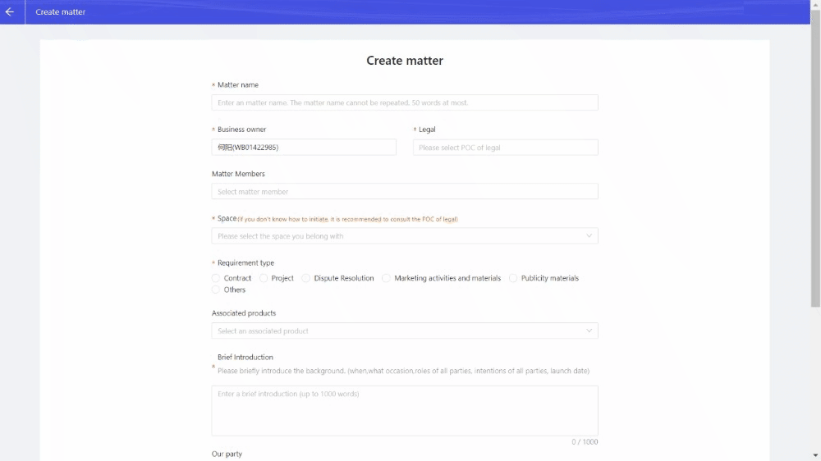

3.2. Review matter

3.2.1. Basic Information Card
If the basic information is incorrect or situation changes, you can click Edit to modify in Basic Information Card.
NB: Space and Requirement type can't be modified.
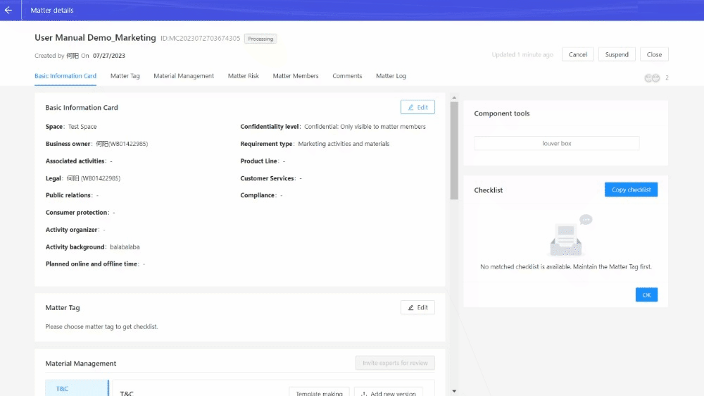

3.2.2. Matter Tag and Checklist
Legal can edit and add matter tags. Different matter tags are associated with different checklist.

Checklist can be used to help legal's review.


3.2.3. Relate Matter
If the matter is related to other matters, you can add related ones.
It is supported that you search by the matter ID or matter name to relate.
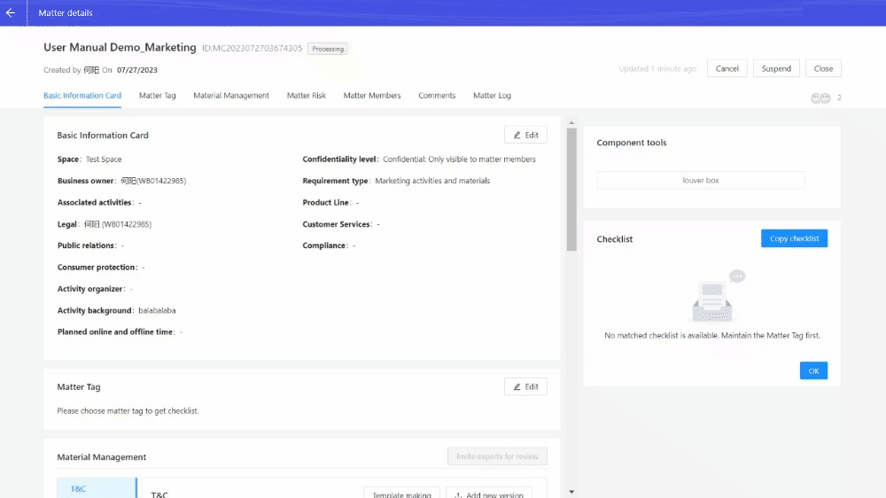

3.2.4. Material Management
- T&C: upload terms and conditions for the campaign
- POSM: upload picture materials for the campaign
- Other materials: upload others except T&C/POSM
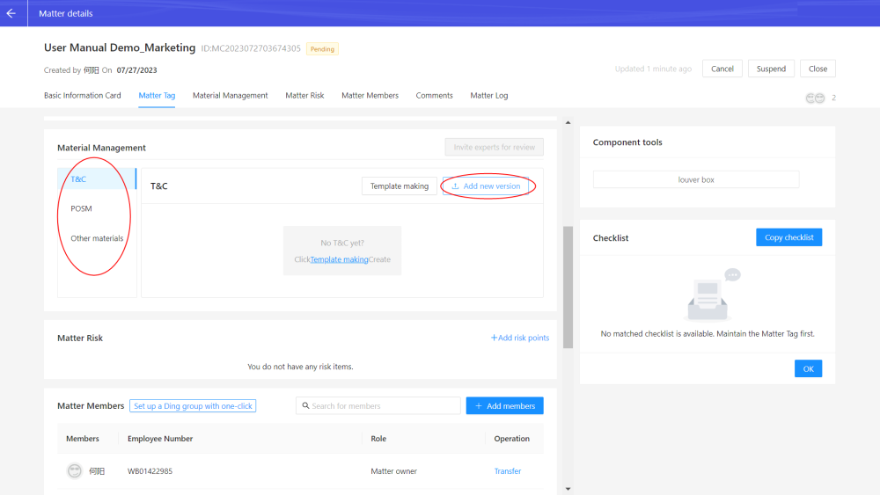

3.2.4.1. Finalize material
Only Legal can finalize marketing material which should be the newest version accepted by all parties.
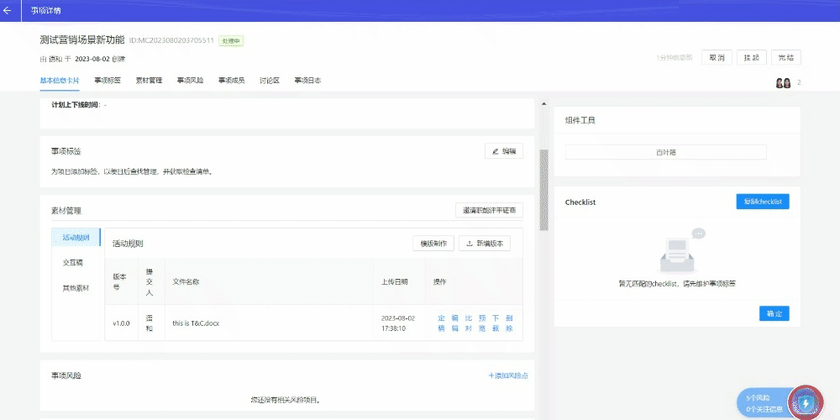

3.2.5. Matter Members
Click Add member, search person by his/her name or employee number. Select and click OK to add person into member list.

Different roles have different permission in matter member management.
Role Permission
 | Business owner | Legal | Members
add new member | √ | √ | √
delete business owner | × | × | ×
delete legal | × | × | ×
delete members | √ | √ | √
transfer | √ | √ | ×
quit | × | × | √

3.2.6. Comments
If you @person in Comments, the person will automatically become a member of the event and receive notifications through Dingding and email.
Files within 100MB are supported to upload in Comments.


3.3. Suspend and Close matter
Business owner and Legal can click Close button to close the matter, and click Suspend button to suspend the matter, which will make all operations in this matter frozen.


3.4. Search matter
Search by keywords of matter name or matter background in the search box is supported.

Click create a new view and name it so that you can save different filters as a view. Switching among diffrent views can help your efficiency improval.


